|  |  |  |  |
| --- | --- | --- | --- |
| **TRIZ** | **Past** | **Present** | **Future** |
| **Super System** | Solid Fuel Rockets | Liquid Fuel Tanking on the Ground | Interplanetary Refueling stations. (Like any fueling stations for cars today) |
| **System** | Ground based fueling tower | Automatic refueling and extraction station for Starship | Automatic refueling and extraction station for all ships with a larger tank and handling more ships at the same time. |
| **Sub System** | Fuel types, Automatic docking, Heatshields | Pumping in vacuum, auto recognition of fuel delivery rockets and rockets to be refueled | Station security, Mult docking capabilities |

System Thinking

The TRIZ diagram’s purpose is to help think about the context of the system in time, looking at future and past challenges.

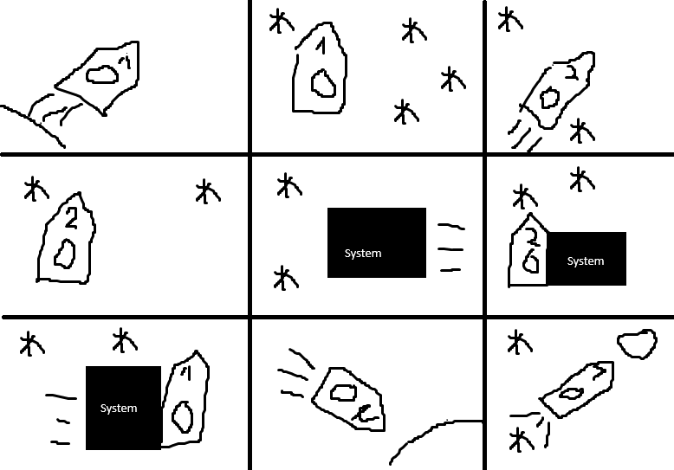

The ConOps diagram’s purpose is to explain the systems function and potentially to make sure all needed functions are included.

The Context diagram is useful to organize the parts that will interact with the system, making sure all problem sources are accounted for.